Courier Management System

**GROUP MEMBERS**

|  |  |
| --- | --- |
| Student1432047 | HAREEM REHAN AFZAL |
| Student1432461 | ABDUL BASIT |
| Student1432059 | IBRAHIM KHATUDA |
| Student1432035 | WAJIHA NADEEM |
| Student1432254 | MUHAMMAD HASSAN |

**FACULTY :Miss Bakhtawar Siraj**

**BATCH CODE :2211B2**

**CURRICULUM :7062**

**ACKNOWLEDGMENT**

We are writing this to declare that  all the  work  which  is  being  written bellow in this Project  is  a record of our own work submitted to  [eprojects@ac.in](mailto:eprojects@ac.in)  in the partial fulfillment for the eProject

We also declare that we have not submitted the material being presented in this Project Report for the award of any other thing elsewhere.

We would also want to appreciate the this concept of eProject as it was very helpful tool for us to Polish our capabilities and skills.

And last but not the least we are extremely grateful to the whole faculty and administration of Aptech, for providing us all the facilities that were mandatory, without which this project could not be a success.

**Projects will be evaluated.**

eProject is a step by step learning environment that closely simulates the classroom and Lab based learning environment into actual implementation. It is a project implementation at your fingertips!! An electronic, live juncture on the machine that allows you to

* Practice step by step i.e. laddered approach.
* Build a larger more robust application.
* Usage of certain utilities in applications designed by user.
* Single program to unified code leading to a complete application.
* Learn implementation of concepts in a phased manner.
* Enhance skills and add value.
* Work on real life projects.
* Give a real life scenario and help to create applications more complicated and useful.

**INTRODUCTION**

Courier management system is currently handled manually by the organisation and facing various challenges in maintaining records and providing information to it’s customers. Tracking and handling of couriers is becoming tedious for the organisation.

**PROPOSED SCENARIO**

Improved Efficiency: The CMS is expected to streamline operations, reducing the time and resources required for manual tracking and routing. Enhanced Customer Experience: Real-time updates and accurate communication will lead to increased customer satisfaction and loyalty. Cost Savings: Optimized routing and efficient operations will result in reduced fuel consumption and operational costs. Scalability: The proposed CMS is designed to accommodate the company's future growth, ensuring scalability and adaptability to evolving logistics needs.

**Home Page:**

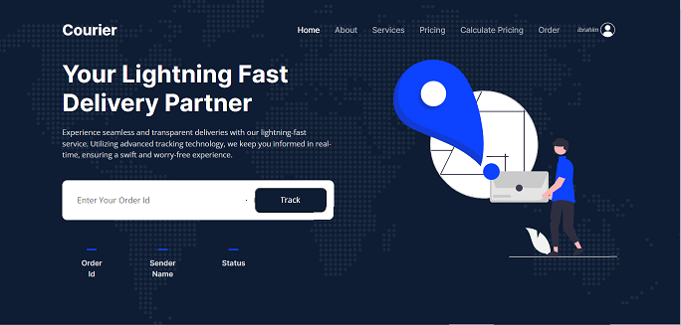

**OUR COMPANIES:**

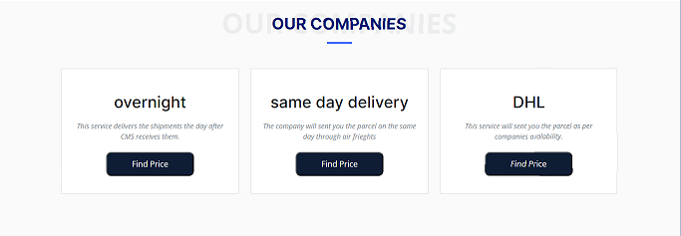

**OUR SERVICES:**

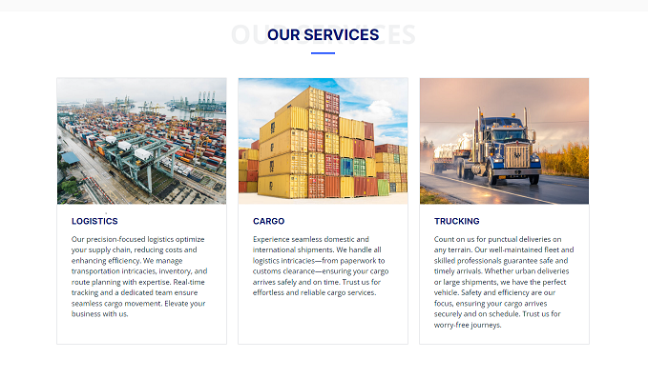

**ABOUT US:**

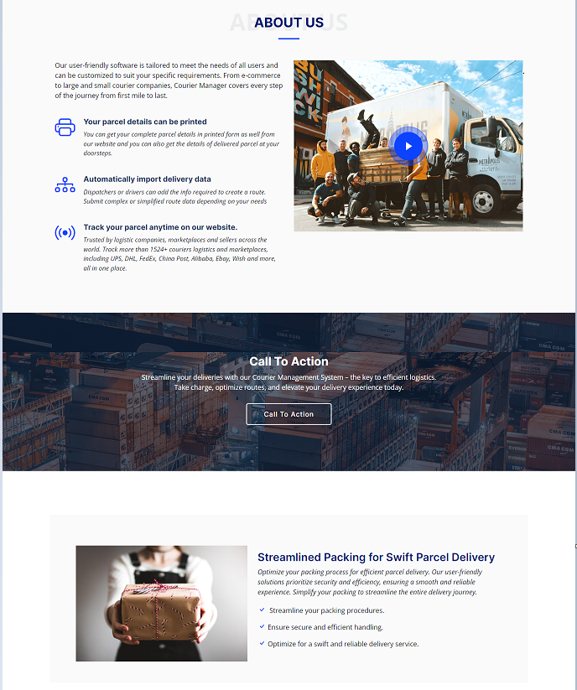

**FEEDBACK & FOOTER:**

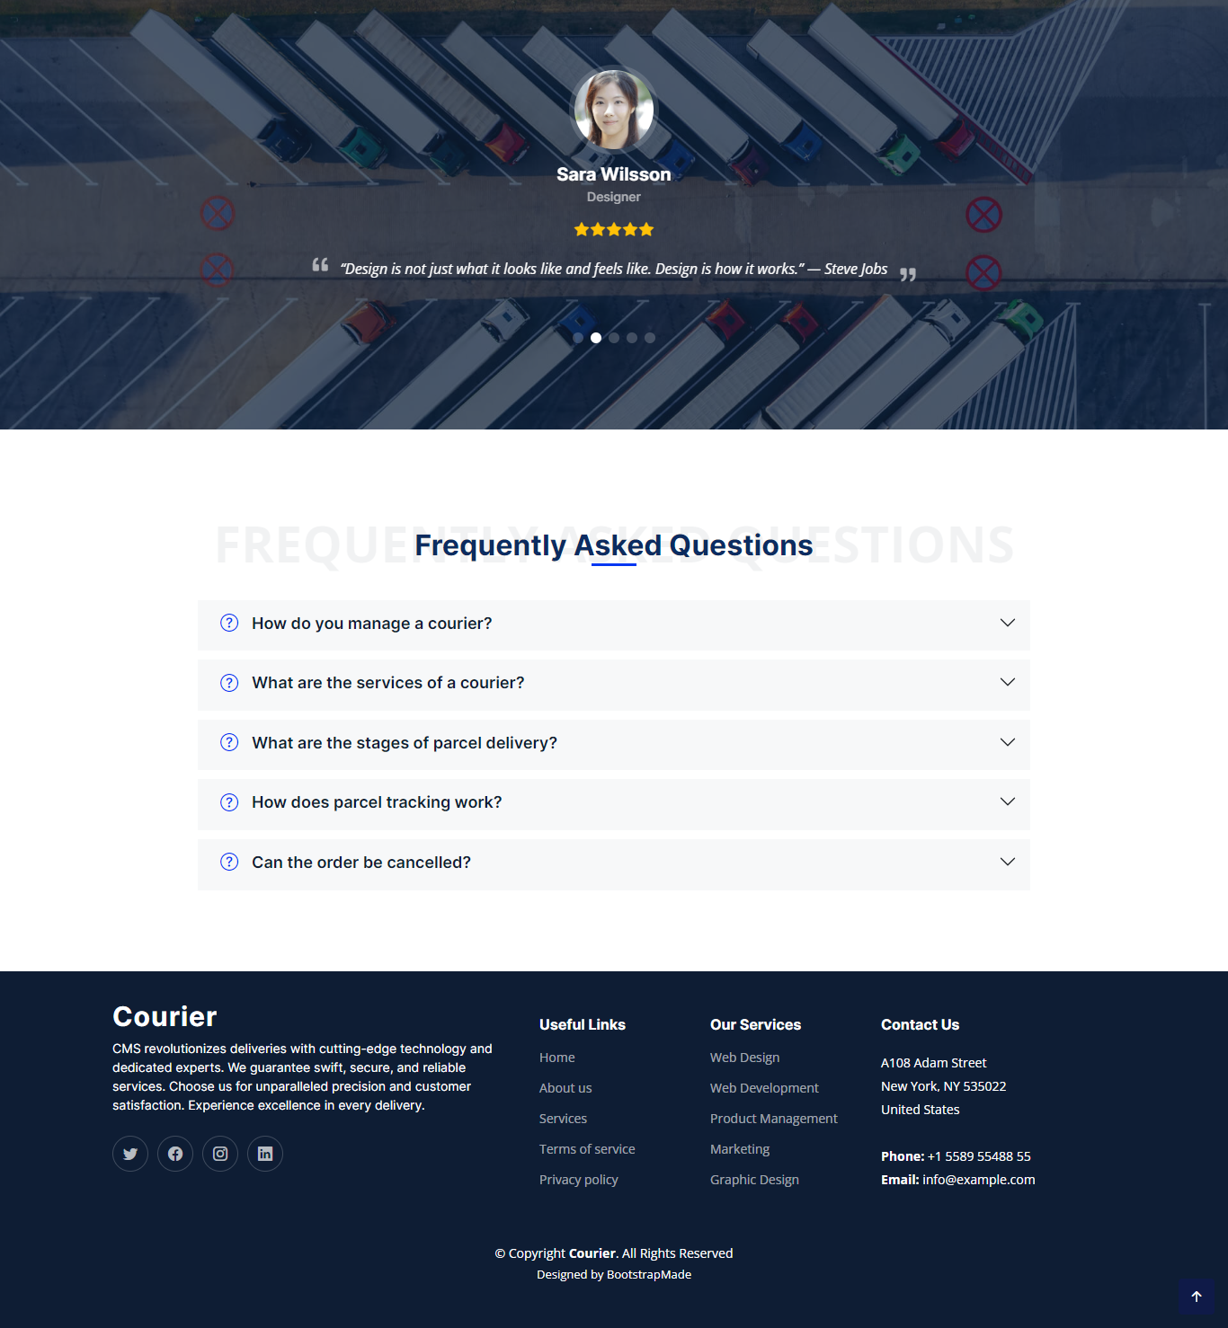

**LOGIN:**

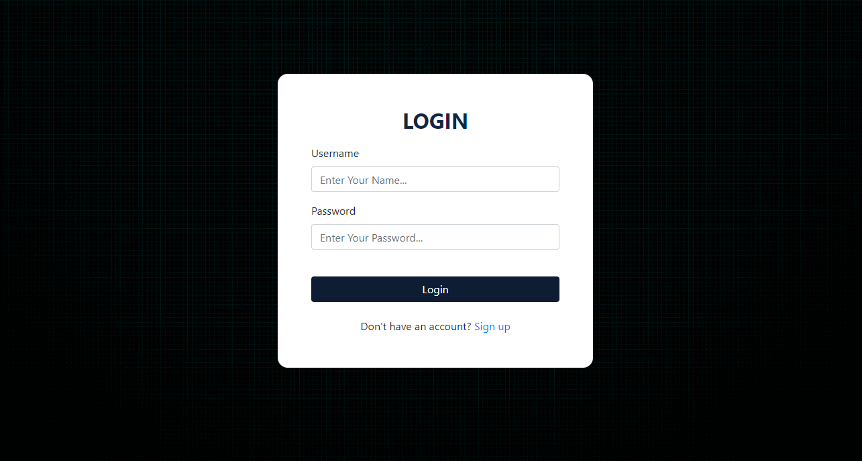

**Note:**

Website View All Some Browser:

Microsoft Edge

Google Chrome

Mozilla Firefox

**CONCLUSION**

After learning whole semester about Web Developing (Dynamically). We are able to do all this at the end of semester and learnt much. E-Project taught us how to do work in limited time and as a team.